Thank you for being interested in the Children’s and Families’ Pastor role at Life Church Bath and for downloading this application pack.

Life Church Bath meets at The Forum, a former cinema in the heart of Bath City Centre. It has a congregation of approximately 550 adults, youth and children. People attend Life Church Bath from the city itself but also from surrounding towns and villages from an average radius of 10 miles. In addition to regular attendees / members we would normally attract several visitors, including families with children, each week.

Our vision statement is to build a radical relevant Church that empowers people to express God’s heart, fulfil their dreams and change the world. Our mission statement is to create a culture where people from every nation and generation can have a genuine encounter with the living God. Our mandate is to see people established in the truth, equipped to fulfil their dreams and empowered to change the world around them. We want everyone to live in the fullness of everything Jesus paid for on the cross, to express the likeness of heaven here on earth and leave a legacy for the generations to come. We believe that the vision and mission statement is true for every age group and our heart is to see it expressed in every area of ministry and in every generation.

Our children’s ministry, Life Kids, currently has 3 groups that meet on a Sunday morning covering babies and children from 0 – 11 years (until the end of primary education): Firecrackers for 1 – 3 year olds, Sparklers for 3 – 5 year olds and Rockets for 5 – 11 year olds.

This is a part time role (3 days per week) to include Sundays and some evenings. When the remaining hours are worked will be open to negotiation. The salary will be dependent on skills and experience but will be in the range of £24K - £27K per annum, pro rata.

Please note that there is a genuine occupational requirement that the holder of this post is a committed Christian and will need to be, or become, a member of Life Church Bath. Life Church Bath is committed to safeguarding and to promoting the welfare of children, young people and vulnerable adults and expects all staff and volunteers to share this commitment.

This post is subject to an enhanced DBS and all relevant pre-employment checks.

If you would like to apply, please complete the application form and send, with a covering letter describing how you meet each of the requirements set out in the person specification, to Amy Wyatt, amy.wyatt@lifechurchbath.com by midnight, Saturday 30th December 2023.

Interviews will be held on Tuesday 16th January 2024.

Role and Responsibilities of the Children’s and Families Pastor

The successful candidate will be responsible for

1. Leading and developing the Children’s Ministry at Life Church Bath to include:

• Facilitating the day to day running of the Children’s Ministry
• Organising a programme and curriculum for Sunday mornings for children in line with the whole church vision and mission
• Consolidating and being responsible for a team of volunteers to deliver the ministry to children, which will include recruiting volunteers, ensuring the ongoing training of the team and supervising the team to ensure that best practice, policies and procedures are followed
• Administering the ministry well through tasks such as the preparation of registers and rotas; maintaining the Life Kids handbook for parents and visitors
• Pastoring the children
• Ensuring good communication, both verbally and written, with children, parents, other ministry areas, the church family and other organisations
• Being aware of changes in culture, legislation and best practice that affects children

2. Developing the role of Families Pastor, creating space for families to connect and friendships to develop.

The successful candidate will

• Work with the Safeguarding coordinator to ensure that all safeguarding policies and procedures are complied with
• Work with the Youth Pastor to ensure smooth transition of children from Children’s Ministry to Youth Ministry
• Work with other members of the pastoral team to care for families

Person Specification of the Children’s and Families’ Pastor
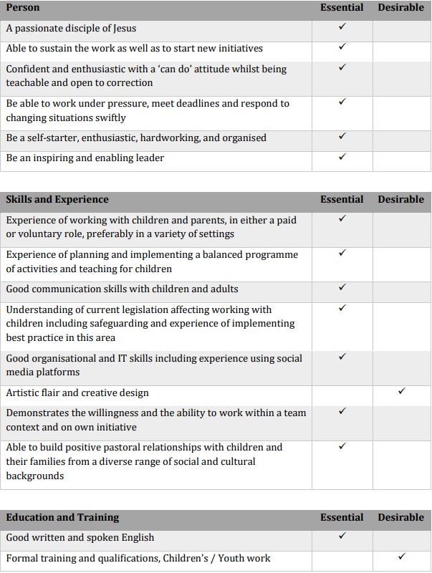

APPLICATION FORM

This form is used for all prospective children's and young people's workers, and those working with vulnerable adults. The information you give us will be kept confidentially by Life Church Bath, unless requested by an appropriate authority. If there is insufficient room to fully answer any question, please continue on a separate sheet.

PERSONAL DETAILS

Full Name
Maiden / Former Name(s)
Date and Place of Birth
Home Address
Postcode
How long have you lived at this address? | years months
If less than 5 years, please give your previous address(es), including postcodes, with dates.
Email address
Daytime tel no:
Evening tel no:

If you are applying for a paid post, do you have the necessary documentation to prove that you are eligible to work in the UK? (Birth certificate, Passport and National Insurance Number)

YES / NO

Please note, if called to interview, you will be required to bring a copy of your current passport, proof of residence and your National Insurance number.

- Please tell us about your Christian experience (ie how long you have been a Christian, which church(es) attended and dates, name of minister / leader, dates and details of the area of your involvement.

- Please give details of previous experience of looking after or working with babies, children, young people or vulnerable adults (as appropriate for the area you will be working in) in either a paid or voluntary capacity. Where appropriate name the church or group and dates.

- Have you any relevant qualifications or appropriate training - either in a paid or voluntary capacity? YES / NO. Please give details.

- Have you ever had an offer to work with children/young people/any group of adults declined?

YES/NO

If yes, please give details.

EMPLOYMENT HISTORY

- Please tell us about your employment history over the last 5 years. Include employer’s name, your job title, dates of employment and reason for leaving.

Employers Name | Job Title | Dates of employment | Reason for leaving

- Are you currently working in any other childcare position or vulnerable adult position in either a voluntary or paid capacity? If yes, please give details:

Name of organisation:
Address:
Contact person in the organisation:
Telephone No:
Email address:
Post you are employed in (please give details of your duties):

REFERENCES

In the space below, please give the names, addresses and telephone numbers of three people who know you well who would be able to give a personal reference. They must not be family members. Please tell us their relationship to you. At least one should be your current or most recent employer, or your tutor. At least one should be able to comment on your work with children, young people or vulnerable adults. At least one must be able to comment on your Christian faith. At least one must not be a member of Life Church Bath.

References will be taken up after a successful interview and before appointment.

Referee 1: Present Employer or Tutor
Name:
Address:
Tel No:
Email Address:
Capacity in which you know them:

Referee 2: Someone who is able to comment on your work with children, young people or vulnerable adults
Name:
Address:
Tel No:
Email Address:
Capacity in which you know them:

Referee 3: Someone who can comment on your Christian faith. This must be someone who knows you well in your current home church (someone in leadership or someone to whom you are accountable) or, if you have recently moved churches, someone who knew you well at your previous church.
Name:
Address:
Tel No:
Email Address:
Capacity in which you know them:

We require all staff & volunteers working with children and vulnerable adults to hold an enhanced DBS check. Please confirm that you understand and agree to a Disclosure check should we decide to appoint you to a post involving working with adults and / children. If called for an interview you will be asking to complete a self-declaration form for an enhanced DBS check to be undertaken should we offer you this position.

DECLARATION

I confirm that the submitted information is correct and complete. I understand and agree to the conditions involving an Enhanced Disclosure check and I am happy to complete the self declaration form if called to interview.

Signed:

Date:

